Urban renewal instead of slum clearance, requires a company to have a workable program before getting money to operate.

1954 act stressed neighborhood conservation and slum prevention.

Walking city areas being demolished for commercial and business areas.

Large amounts of cities being demolished for city centers.

Communities and walking cities being destroyed and cut off from each other.

Detroit is gutted, and highways are made to take people directly from the suburbs to their buildings without interacting with the city.

City attempts a saving throw using urban renewal. Reimagine the city as a commercial center.

Detroit was too disorganixed and mixed up building wise.

Ideally the highways would being people to work in the commercial core to be built

Many projects were very optimistic and hopeful, but did not turn out that way.

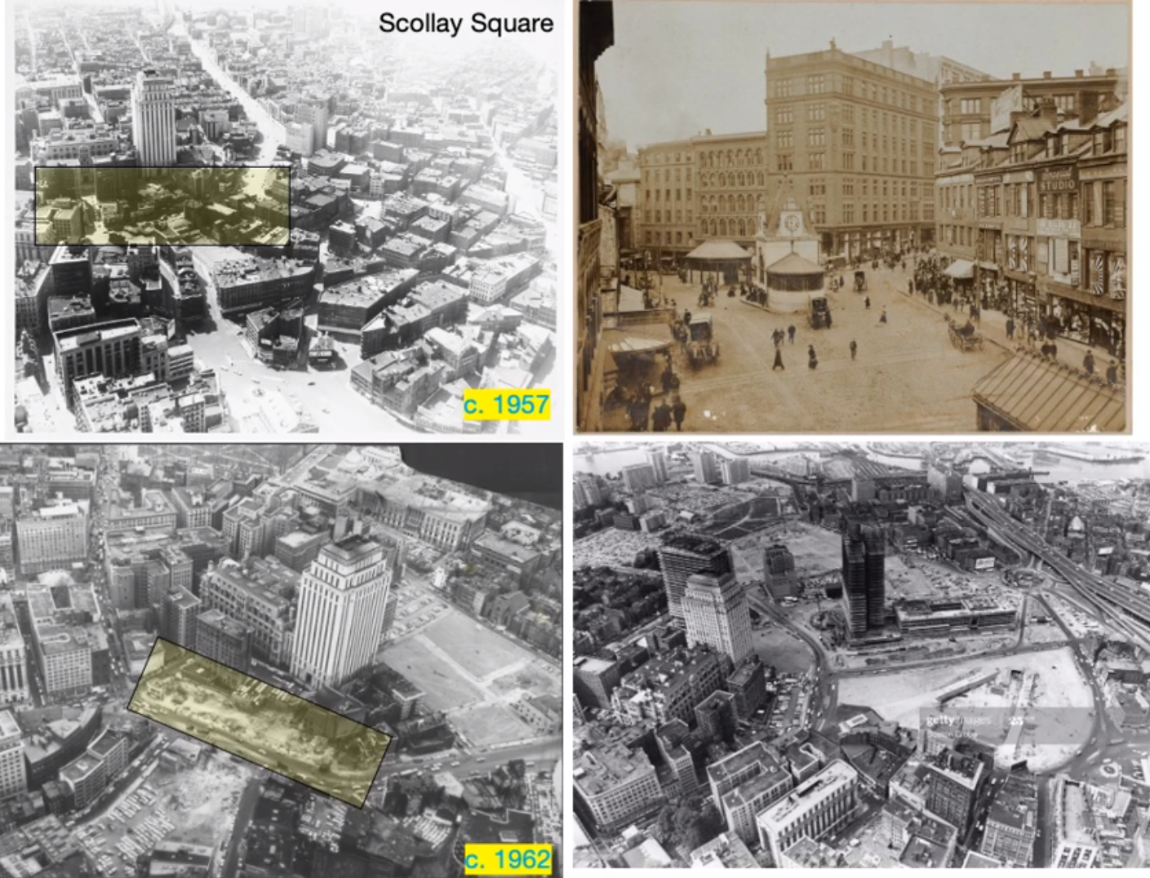

Enormous amount of scollay square demolished, ~20,000 residents

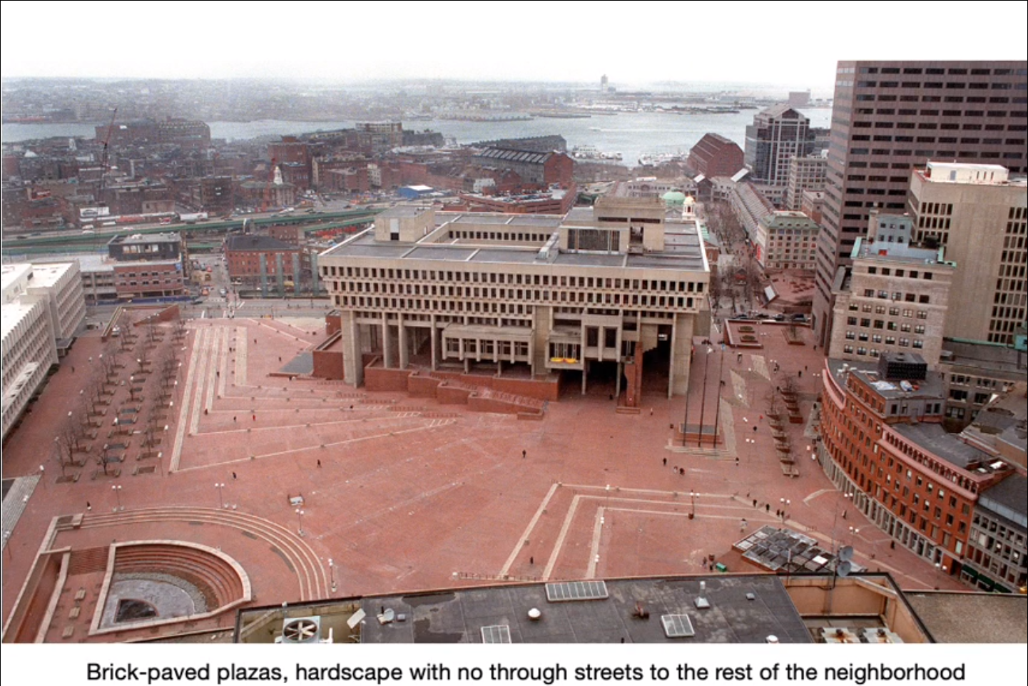

City center building that was meant to be a hub of activity, but is generally mostly deserted and disliked. (Brick paving intentionally stops people from driving)

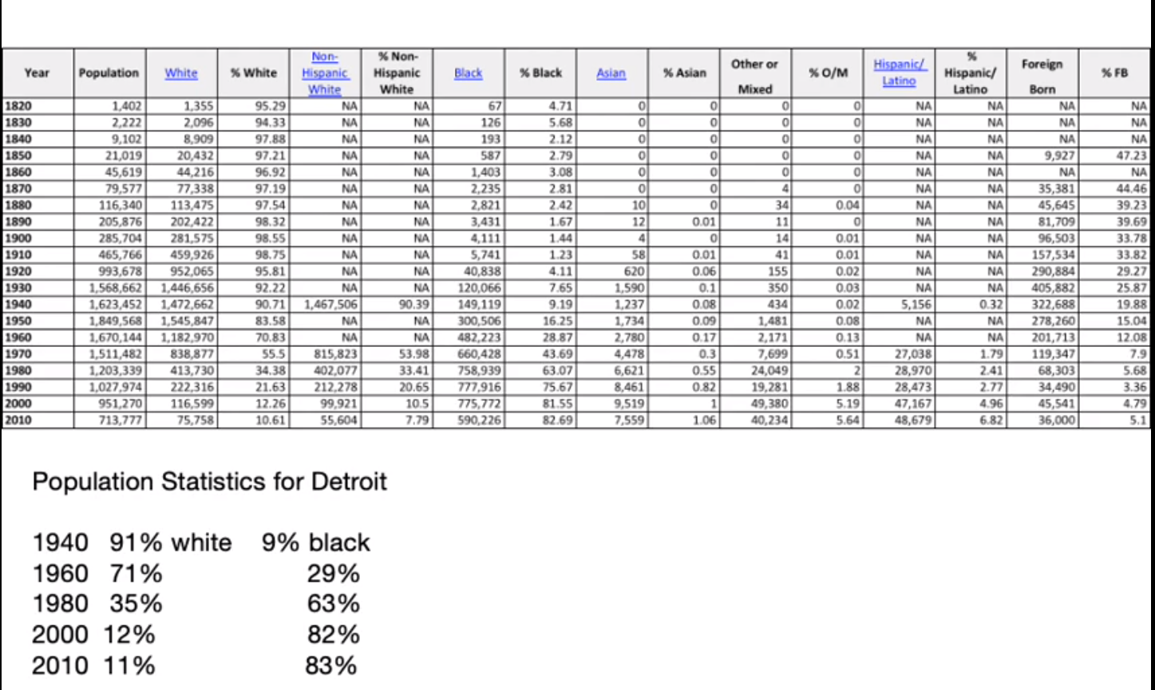

Detroit’s % residences, white people leaving Detroit, population dropping from 1960 to now.

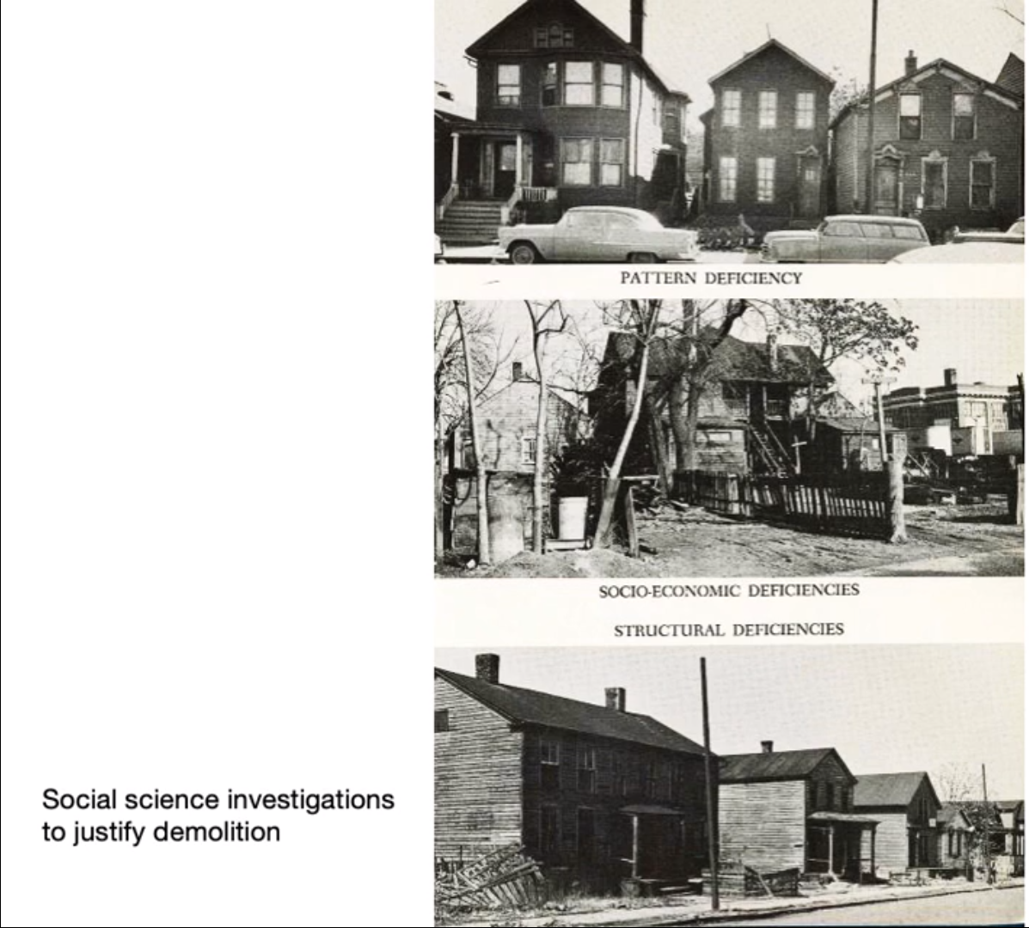

Issues with Detroit housing